In this assignment, I will cover the implementation of

Zuul mapping and routing service, using two additional services:

1. Organization-New – to differ between the two organization when routing.
2. Special Routes – to support different request routing between services.

Most of the implementation during this assignment will be through re-configuring the application.yml of the Zuul project. Through different executions, the request will be routed to either “old” or “new” organization services, using the Special Routes service.

Running mvn clean package docker:build :

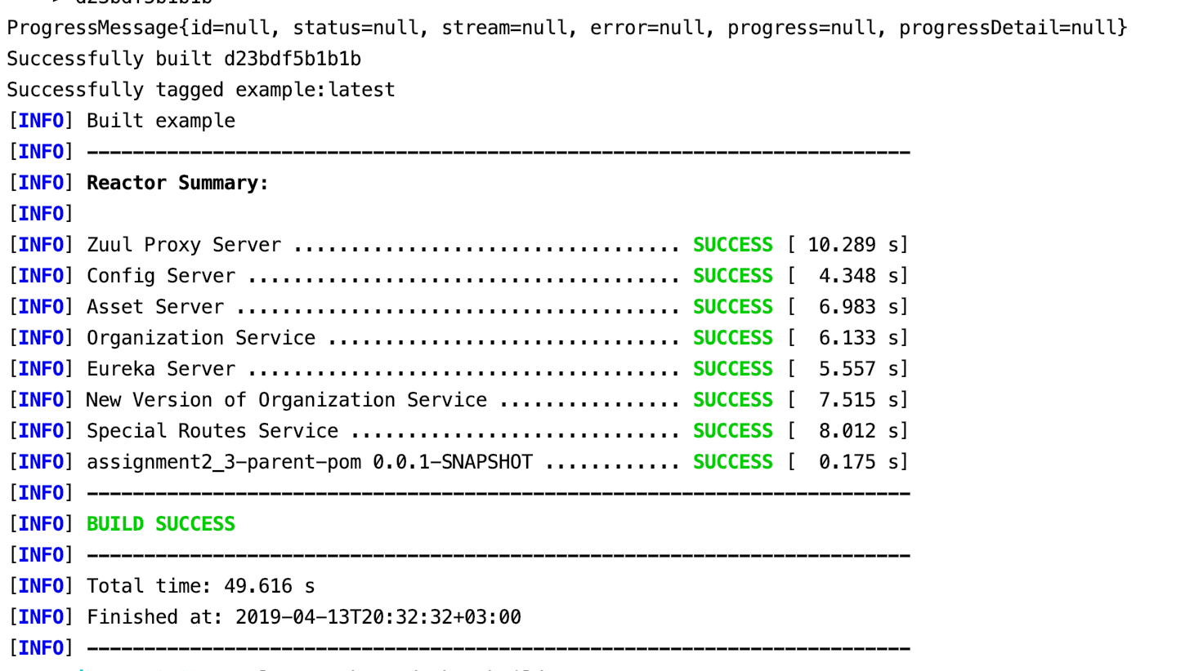

**docker-compose -f docker/common/docker-compose.yml up**

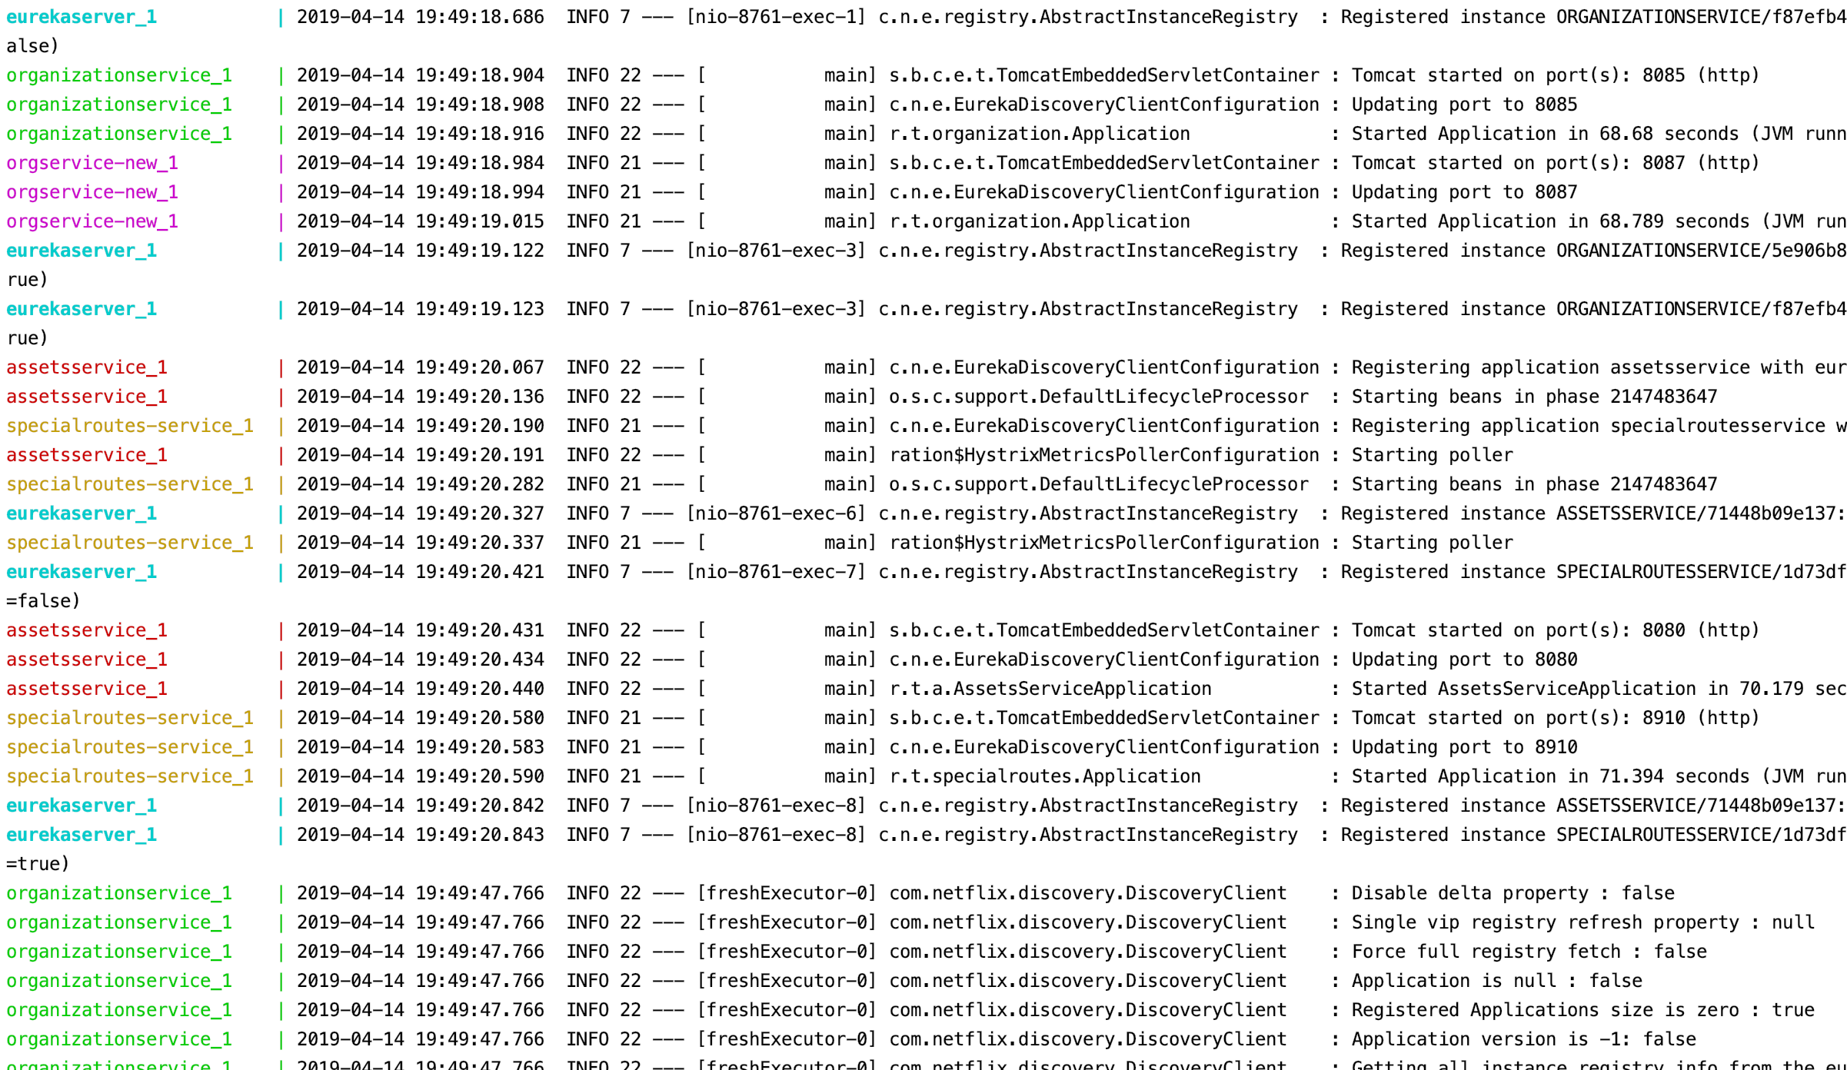

Use Case 1 - Zuul’s application.yml files mappings are commented out:

Request to Organization service :

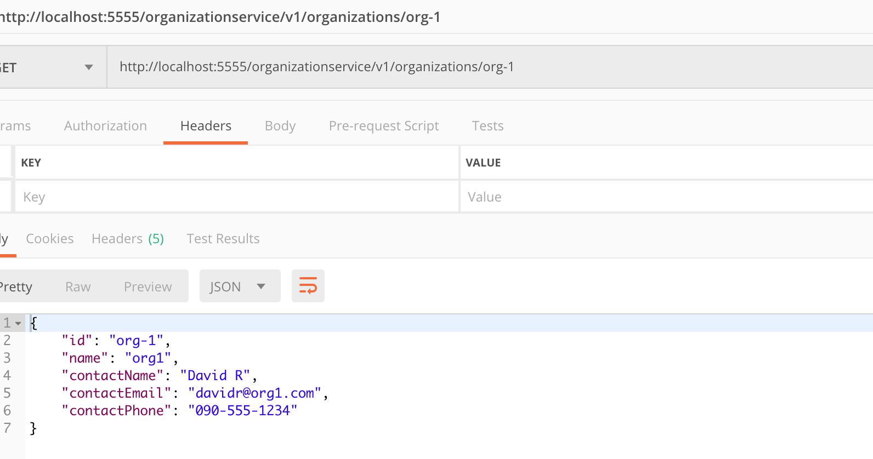

Zuul’s service route mapping:

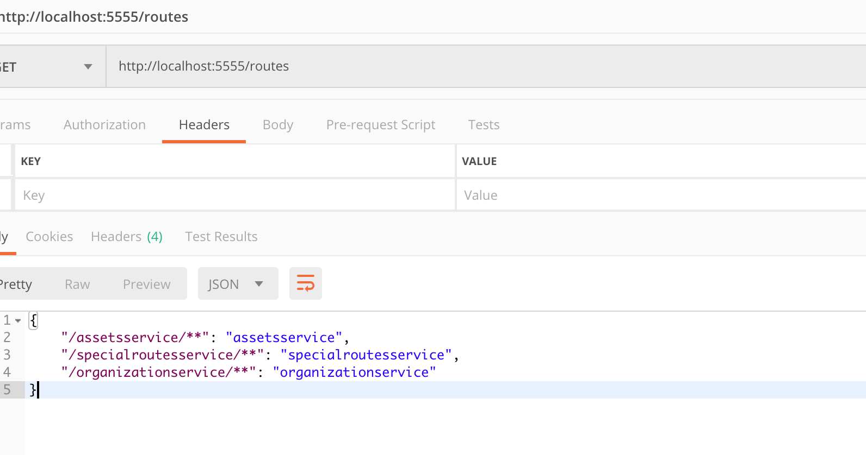

Use Case 2 -Zuul’s application.yml – shortening the organization name to /organization/**:

Getting an organization:

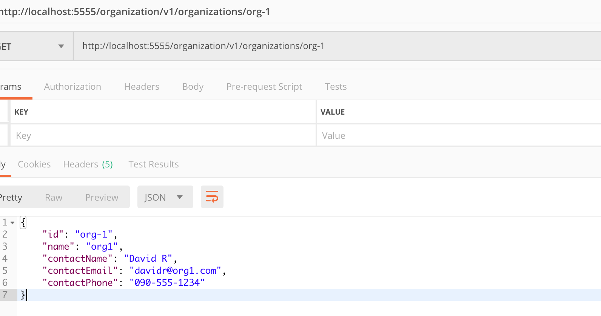

Checking routes:

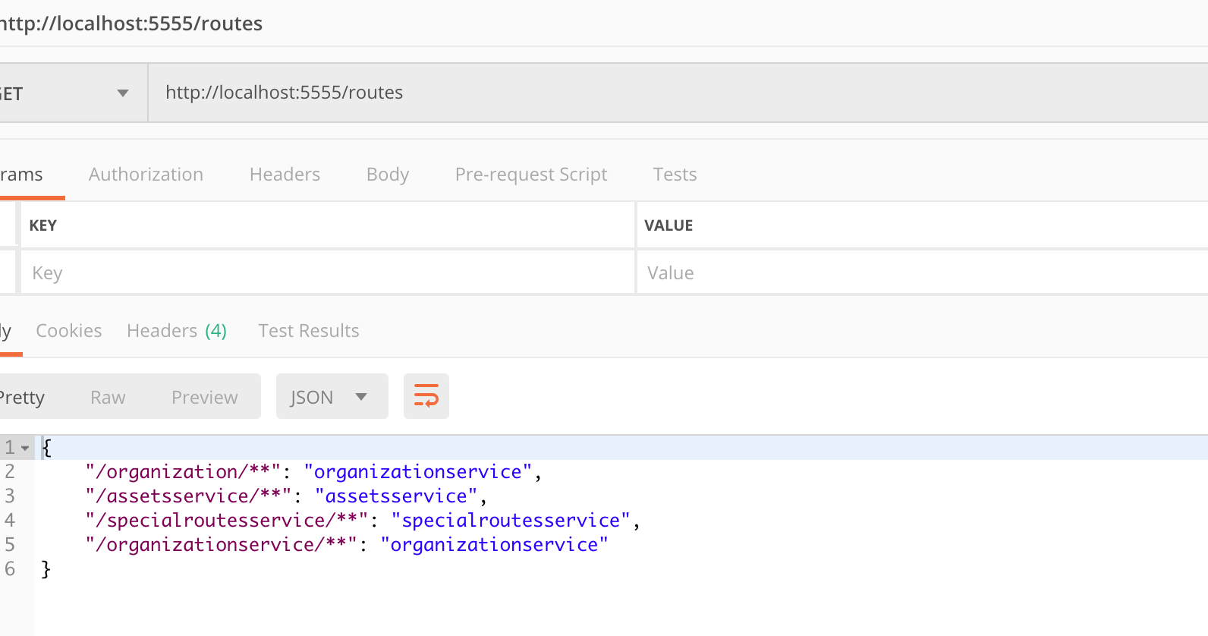

Use Case 3 – mapping assetsservice to /assets/** :

Getting organization:

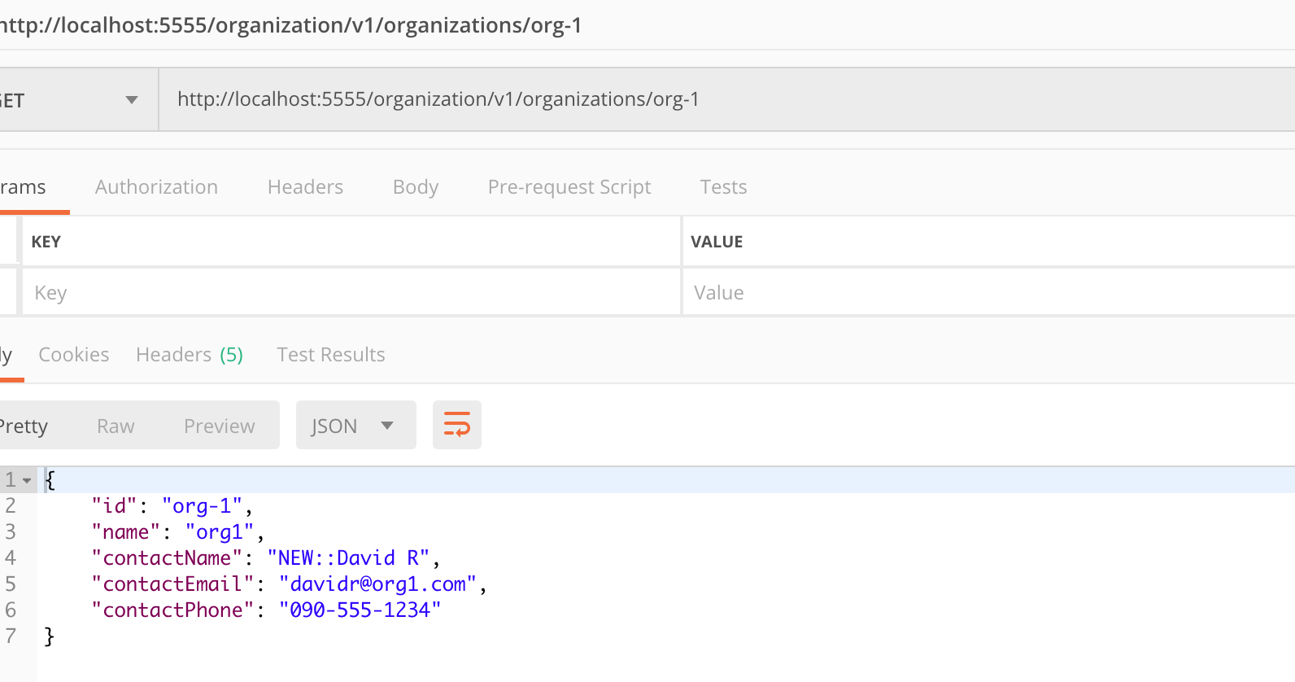

Checking routes:

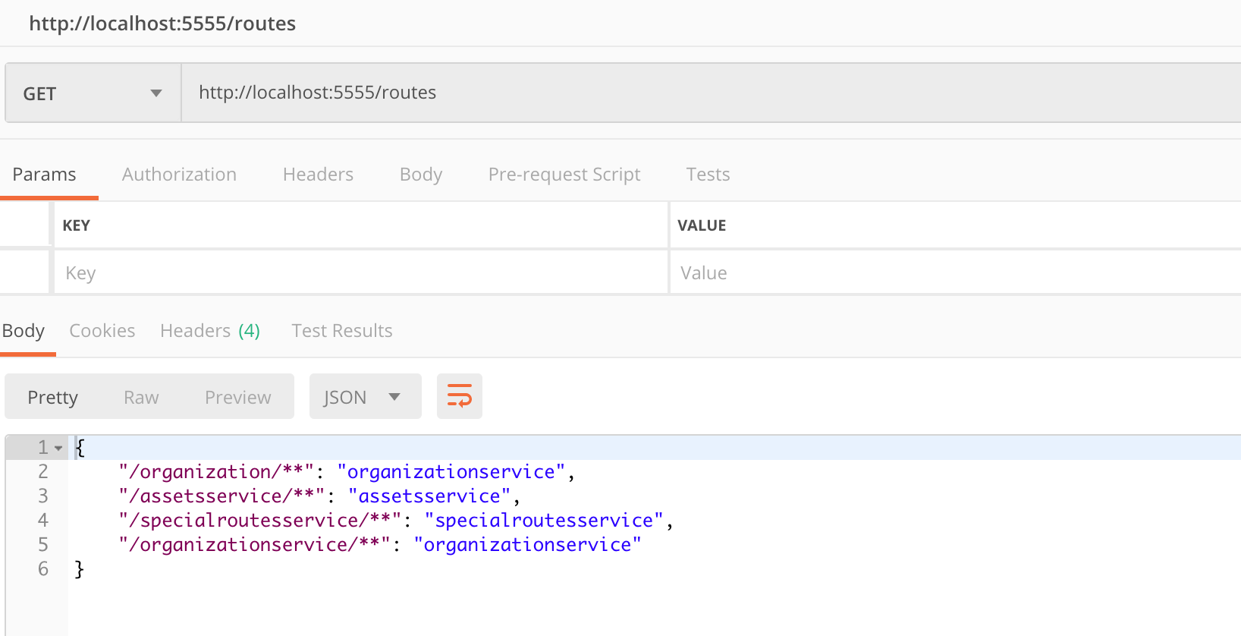

Use Case 4 – organizationservice to ignored-services:

Getting organization:

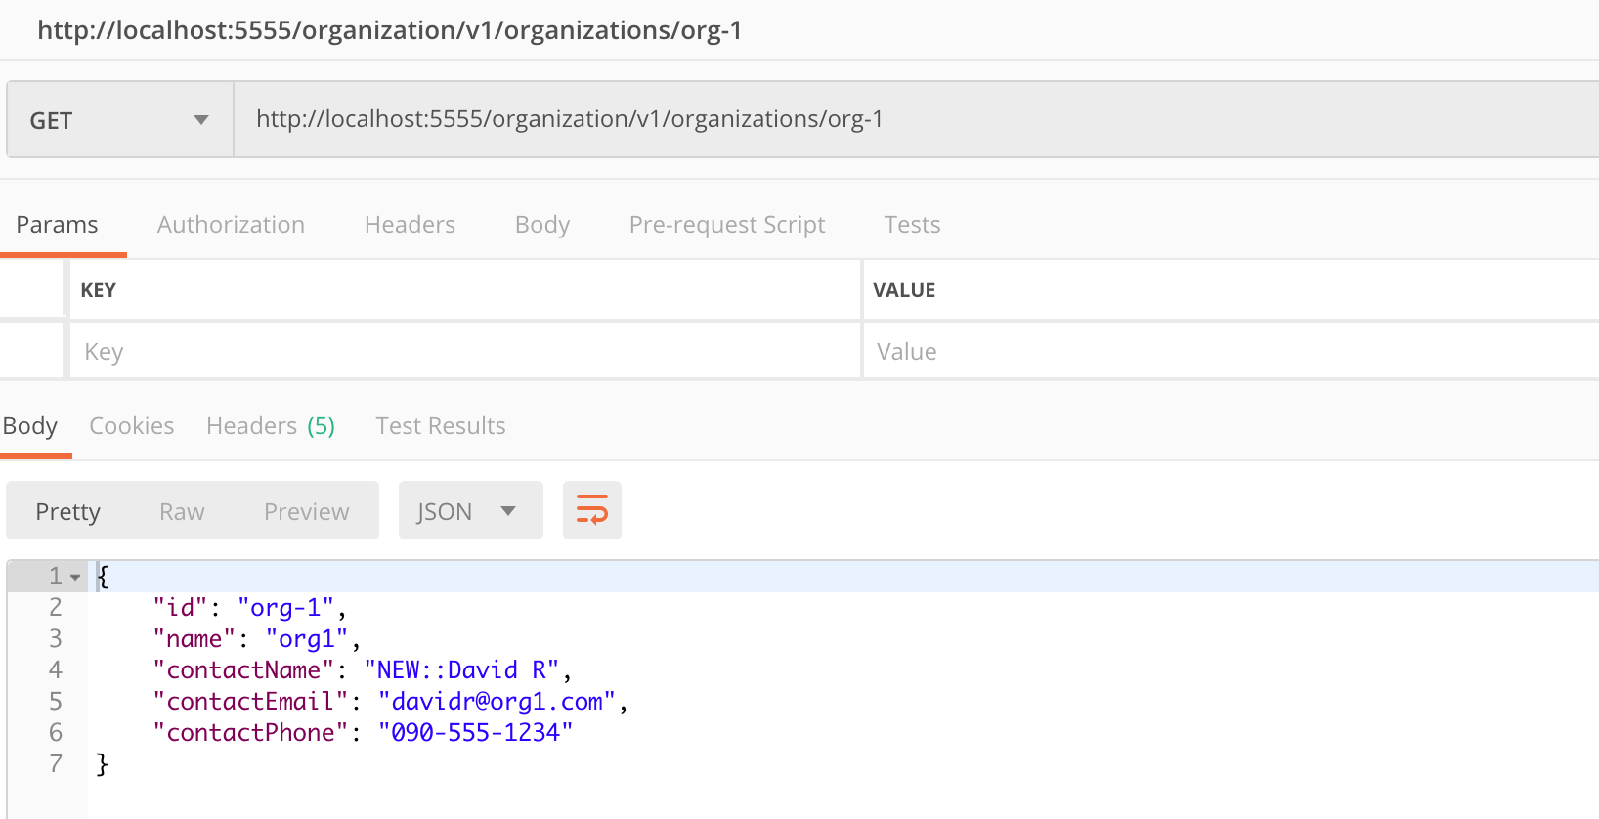

Checking routes:



Use Case 5 – applying /api route as prefix:

Getting organization:

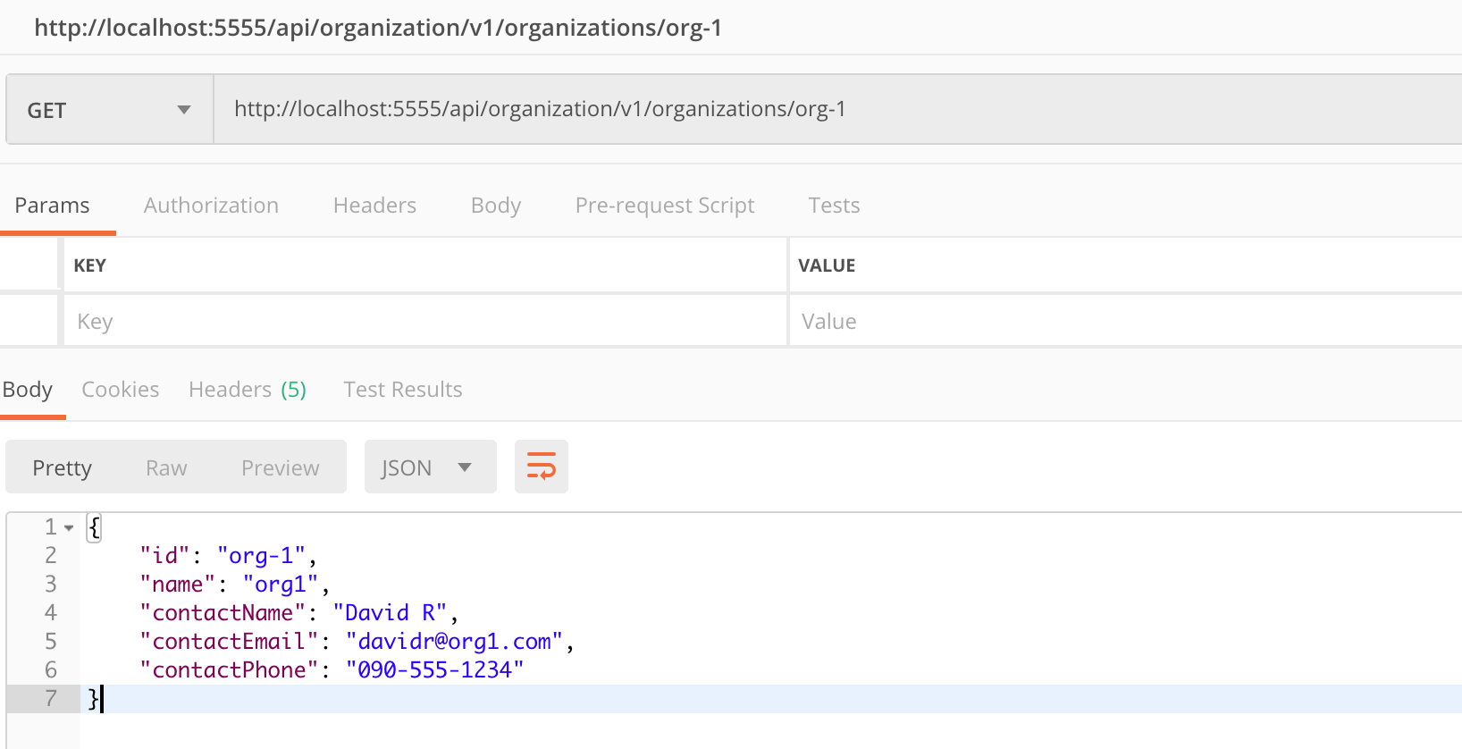

Checking routes:

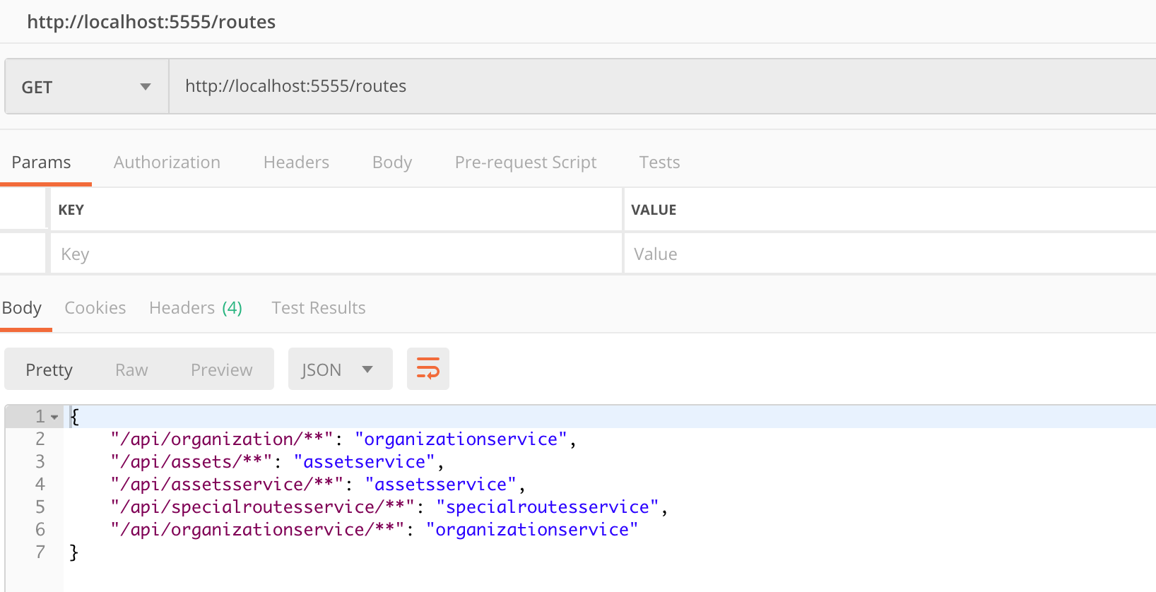

Use Case 6 – map assetservice to static route with port 8081:

Getting organization:

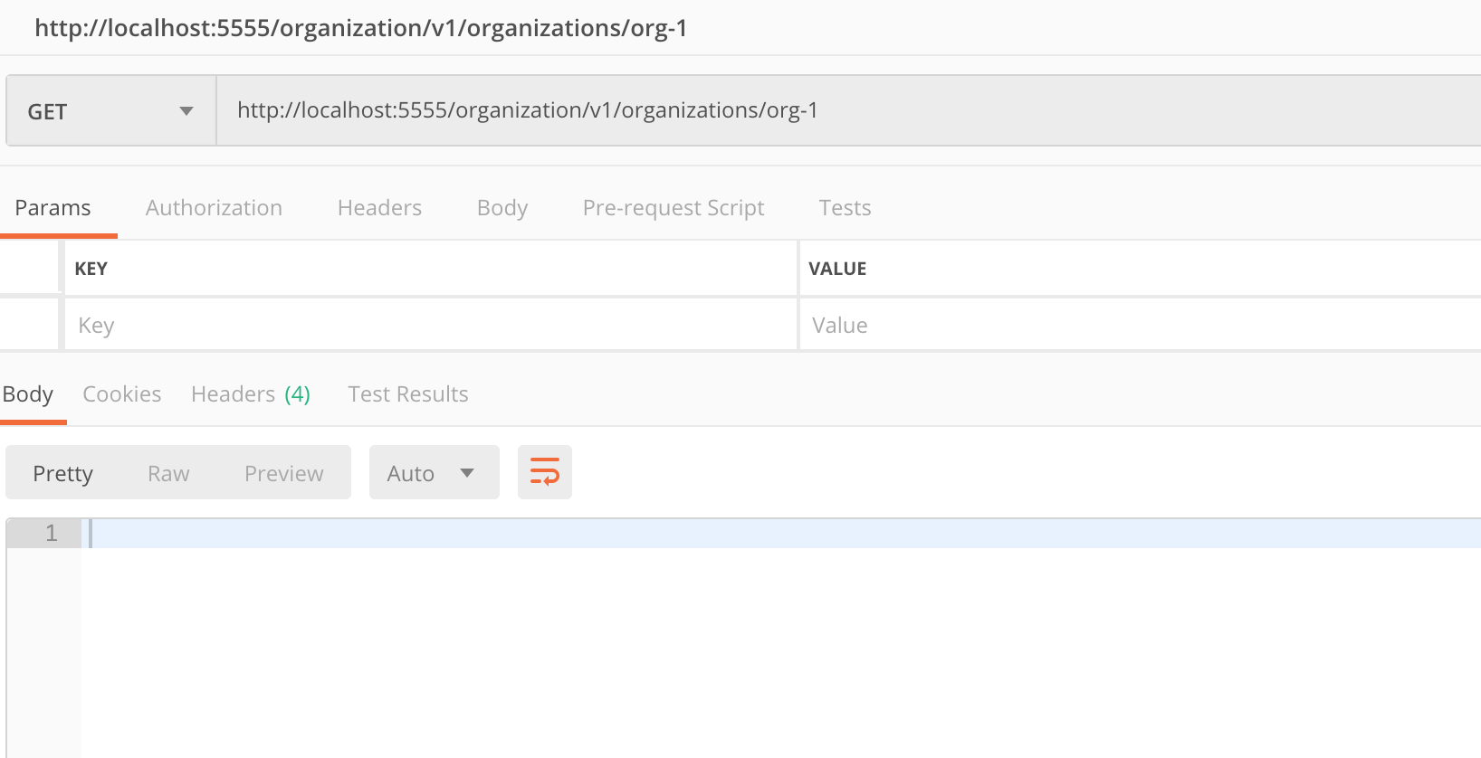

Checking routes:

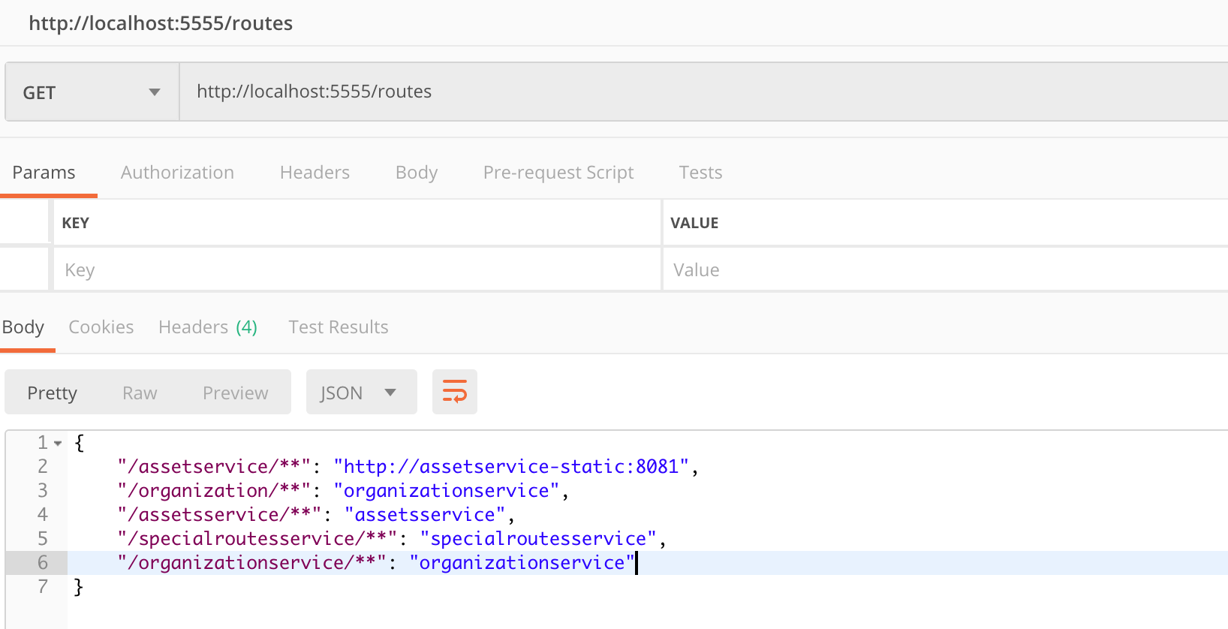

Use Case 7 – map assetservice to static route with port 8081 & 8082:

Check routes, without /api prefix:

